CHAPTER I
INTRODUCTION

Nowadays, many people use technology to make their work easy. With computers or systems, business tasks are now faster. Alog Laundry Daily Record System was created to make it easier to manage the business instead of manually recording each transaction, it is now done using a computer. With this system, it is easy to see information such as the number of customers, number of employees, total transactions, and total income. There is also a dashboard where you can see the summary of the business. This system was created to make it faster to receive laundry, record status, and see the business's income every day. This is simple but a big help for the better management of the laundry shop.
Objectives of the Study
Specific Objectives
- To be able employees to add record or add new laundry transaction.
- To be able admin and staff to view transaction history.
- To be able employees to update new transaction status.
- To be able admin and employees to monitor customer details and laundry record.
- To be able admin to track important summary of laundry.
Scope and Limitations of the Study
Scope of the Study
The Alog Laundry Daily Record System is capable of the following:

Laundry Order
Allows employee to input new laundry transactions including customer details, total basket used of customer and detergent. Customers cannot check laundry status or transaction history admin and employee only.
Transaction History
Allows the admin and employees to view all past laundry records per customer, including the date, status, customer name, and other information about the customer's laundry. Once records are saved, employees or admins cannot correct errors or update transactions.
Laundry Status Update
Allows employees to update the status of a customer's laundry after it has been picked up. Cannot edit the status after employee update the laundry status of customer.
Customer Profile Management
Allows admin and employees to manage and monitor a database of customers, including their
name, address, contact information, and complete transaction history. The system does not
support uploading customer photos or identification.

Dashboard and Analytics
Provides a real-time summary of important data including total employees, total customers, number of laundry transactions, total revenue, and laundry status picked up or not. These help the admin track the performance and status of the business. No visual chart or graphs like top customer total income per day or per month.

Limitations of the Study
This study focuses only on recording laundry transactions to help the admin monitor what is happening in the laundry shop and does not allow customers to make online requests. Only employees can record customer information and transactions.

CHAPTER II
REVIEW OF RELATED LITERATURE AND STUDIES

FOREIGN LITERATURE

A Smart Approach Laundry Management System: A Tool to Integrate for Next Generation Life Style
According to Rastogi et al. (2023), implementing a digital laundry management system significantly improves how transactions and records are handled. Their study problems in traditional laundry shops, such as lost records and incorrect tracking of customer orders. the key is that automated recording of laundry orders helps minimize errors and keeps customer information organized and accessible.
Smart Laundry System Laundry Service

Qing and Omar (2023) emphasized the challenges faced by laundry businesses in using traditional, manual management systems. These include wasted time, difficulty in tracking transactions, and limited methods for managing customer records.
LOCAL LITERATURE
The Evolution of Laundry Businesses in the Philippines: From Traditional to Tech-Savvy
According to ATMICX (2024), the laundry industry in the Philippines has shifted from small, manual operations to modern, tech-enabled services. With the growing demand for convenience, many businesses now use mobile apps and digital platforms for scheduling, order tracking, and payments. These innovations have improved efficiency for both customers and owners.

MEASURING THE OPERATIONAL EFFICIENCY IN LAUNDRY SERVICES AT LAHUG CEBU CITY: A DATA-ENVELOPMENT ANALYSIS (DEA)
Santos, Montejo, and Saligo (2025) conducted a study on the laundry businesses in Lahug, Cebu City. Their research found that many laundry shops had problems in how they manage their work, which affects the quality of service and business performance. The study need better management, organized systems, to improved work processes which is to create a transaction recording system that improves accuracy and reduces manual tasks.

CHAPTER III
RESEARCH METHODOLOGY AND DESIGN
Software Methodology
I used the Agile methodology because it helped me improve the system step by step while I was building it. My project included different features such as Employee can add record customer to laundry and track the customer also to update status and the admin is to monitor all record. I expected that some changes would happen during development, and Agile allowed me to adjust easily. I worked in small parts called sprints, where I focused on one feature at a time, tested it, got feedback, and made improvements. This helped me create a system that really fits what the users need.

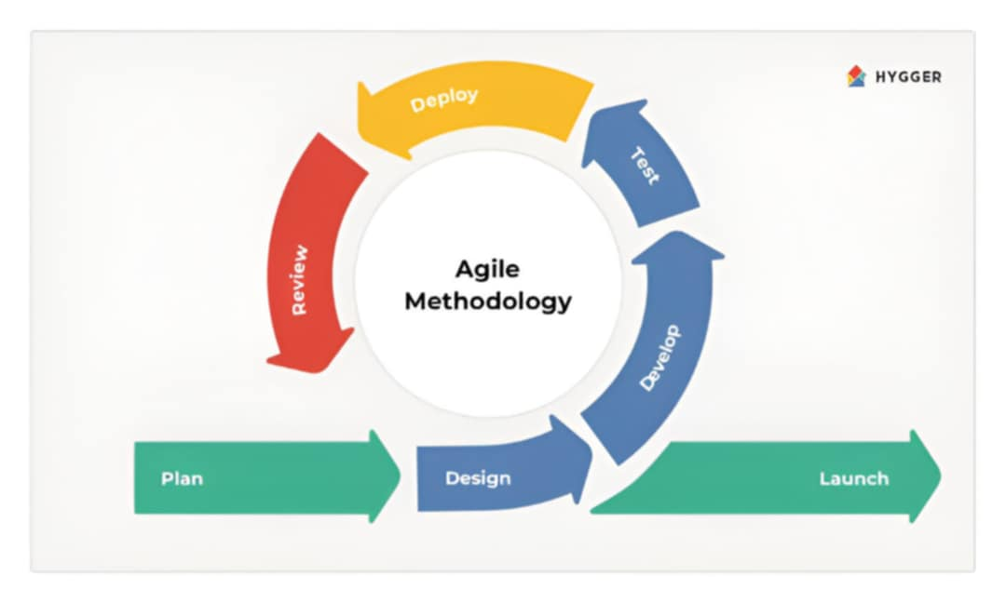

- Plan:
I start by identifying the specific problems faced by the laundry shop such as tracking customer orders, monitoring total basket and detergent usage. I created user stories like a staff member needs to update the status of a laundry order or admin needs to view daily completed services.
- Design:
I designed the interface and database structure were made for pages like the add laundry dashboard, transaction history, and status tracking.
- Develop:
Once the designs were ready, I started building the system one part at a time. For example, first was about customer order input and status updates next tackled payment tracking, transaction history. Code was written using Python Tkinter for the interface and MySQL for database.
- Test:
Each feature was tested to make sure it worked properly. I checked if buttons functioned, if data saved correctly, and if the pages connected smoothly. Bugs were fixed as we went.
- Deploy:
When a feature was working well, I deployed it to a test version to try it out.
- Review:
After every part of development, I checked the system to see if everything was working as planned. I tested the features, looked for problems, and fixed them.

- Launch:
After all major features were built and tested, we finalized the system and prepared it for full launch.

